WALKER COUNTY SHERIFF’S OFFICE
2001 2ND Avenue
Jasper, AL 35501
(205) 302-6464

IDENTITY THEFT PACKET INSTRUCTION SHEET

This is an Identity Theft packet that you may fill out. Step by step instructions are as follows:

1. Fill out the IDENTITY CRIME INCIDENT FORM.
2. Make a copy of this entire Identity Theft packet and return the original to the Sheriff’s Office.
3. Make a copy of the Police Report and keep for your records.
4. Gather documents from the business showing where your identity was used to purchase or
obtain a service.
5. Obtain credit reports from Experian (1-888-397-3742), TransUnion (1-800-680-7289), and
Equifax (1-800-525-6285). Return copies of the credit report with the Identity Theft packet.
6. Contact your financial institions (banks, etc.) and make them aware of your situations. Change
the passwords of your online accounts.
7. Contact the Social Security Administration hotline if your social security number was used to
commit the fraud. 1-800-269-0271.
8. Fill out the Identity Theft Affidavit that is attached to this packet. Make as many copies as you
need and send it to the financial institutions and businesses where you have been victimized.

If you follow the instructions on this page, this should help prevent further acts of fraud against you

If you do not wish to prosecute the suspect who used your identity, you need to still follow the
instructions on this page except there is no need to return a copy of this packet to the Sheriff’s
Office.

This packet consists of the following:
a. Cover Sheet (1 page)
b. Identity Theft Affidavit (5 pages)
c. Annual Credit Report Request Form (1 page)
d. Identity Crime Incident Detail Form (11 pages)
e. Contact Sheet for the three credit reporting agencies (1 page)

*Most of the information requested in this form was copied from the United States Secret Service – Identity Crime Resources for Law Enforcement. It was combined into one document for ease of availability.
Name: __________________________________ Phone Number: ________________________ Page 1 of 5

IDENTITY THEFT AFFIDAVIT

Victim Information

(1) My full legal name is ___________________________________________________________________
(First) (Middle) (Last) (Jr, Sr, III, etc.)

(2) (If different from above) When the events described in this affidavit took place, I was known as:

_____________________________________________________________________________________
(First) (Middle) (Last) (Jr, Sr, III, etc)

(3) My date of birth is ___________________________
(month/day/year)

(4) My Social Security Number is : _______ - ________ - ________

(5) My driver’s license or ID card Number is : ________________________ State of Issue: _____________

(6) My current address is ___________________________________________________________________

City: ______________________ State: _________________ Zip code: _______________________

(7) I have lived at this address since _________________________
(month/year)

(8) (If different from above) When the events described in this affidavit took place, my address was:

Address: __________________________ City: ________________ State: ______ Zip Code: _________

(9) I lived at the address in Item #8 from ______________________ until ________________________
(month/year) (month/year)

(10) My daytime telephone number is : ( ______ ) _________ - __________

My evening telephone number is : ( ______ ) _________ - ___________

My work telephone number is : ( ______ ) _________ - ___________

My cell phone number is : ( ______ ) _________ - ___________

DO NOT SEND THIS AFFIDAVIT TO THE FTC OR ANY OTHER GOVERNMENT AGENCY
Name: __________________________________ Phone Number: ________________________ Page 2 of 5
(IDENTITY THEFT AFFIDAVIT)

How the Fraud Occurred

Check all that apply for items 11 to 17:

(11)  I did NOT authorize anyone to use my name or personal information to seek the money, credit, loans,
goods or services described in this report.

(12)  I did NOT receive any benefit, money, goods or services as a result of the events described in this
report.

(13) My identification documents (for example: credit cards, birth certificate, driver’s license, social
security card, etc) were :  stolen  lost on or about ______________________________
(month/day/year)
(14) To the best of my knowledge and belief, the following person(s) used my information (for example: my
name, address, date of birth, existing account numbers, social security number, mother’s maiden name,
etc.) orthe following person(s) used my identification documents to get money, credit, loans, goods or
services without my knowledge, consent, or authorization:

_______________________________________ _______________________________________
Name (if known) Name (if known)

_______________________________________ _______________________________________
Address (if known) Address (if known)

_______________________________________ _______________________________________
Phone Number(s) (if known) Phone Number(s) (if known)

_______________________________________ _______________________________________
Additional Information (if known) Additional Information (if known)

(15)  I do NOT know who used my information or identification documents to get money, credit, loans,
goods or services without my knowledge, consent, or authorization.

(16)  Additional comments: (for example, description of the fraud, which documents or information were
used or how the identity thief may have gained access to your information.)

___________________________________________________________________________________________

___________________________________________________________________________________________

___________________________________________________________________________________________

___________________________________________________________________________________________
(Attach additional pages as necessary – Label them as ID Theft Affidavit Attachments)

DO NOT SEND THIS AFFIDAVIT TO THE FTC OR ANY OTHER GOVERNMENTAL AGENCY

Name: __________________________________ Phone Number: ________________________ Page 3 of 5

Victim’s Law Enforcement Actions

(17) (check one) I  am  am NOT willing to assist in the prosecution of the person(s) who committed
this fraud.

(18) (check one) I  am  am NOT authorizing the release of this information to law enforcement for
the purpose of assisting them in the investigation and prosecution of the person(s) who committed this
fraud.

(19) (check all that apply) I  have  have NOT reported the events described in this affidavit to the
police or other law enforcement agency. The police  did  did NOT write a report. In the event you
have contacted the police or other law enforcement agency, please complete the following:

_________________________________ ______________________________________
(Agency #1) (Officer/Agency personnel taking report)

_________________________________ ______________________________________
(Date of report) (Case Number)

_________________________________ ______________________________________
(Phone number of the agency) (email address of Officer/Agency, if known)

_________________________________ ______________________________________
(Agency #2) (Officer/Agency personnel taking report)

_________________________________ ______________________________________
(Date of report) (Case Number)

_________________________________ ______________________________________
(Phone number of the agency) (email address of Officer/Agency, if known)

Documentation Checklist

Please indicate the supporting documentation you are able to provide to the companies you plan to notify. Attach copies (NOT originals) of the police report to the affidavit before sending it to the companies.

(20) A copy is attached of a valid government-issued-photo-identification card (for example: your driver’s
license, state-issued ID card or your passport). If you are under 16 years old and don’t have a photo-ID,
you may submit a copy of your birth certificate or a copy of your official school records showing your
enrollment in the school and place of residence.

(21)  Attached is Proof of residency during the time the disputed bill occurred, the loan was made or the
other event took place (for example: a rental/lease agreement in your name, a copy of a water bill or
power bill, or a copy of an insurance bill)

DO NOT SEND THIS AFFIDAVIT TO THE FTC OR ANY OTHER GOVERNMENTAL AGENCY

Name: __________________________________ Phone Number: ________________________ Page 4 of 5

(22)  A copy of the report you filed with the police or sheriff’s department is attached. If you are unable to
obtain a report or report number from the police, please indicate that in Item # 19. Some companies
only need the report case number, not an actual copy of the report. You may want to check with each
company to verify this.

Signature

I certify that, to the best of my knowledge and belief, all the information on and attached to this affidavit is true, correct, and complete and made in good faith. I also understand that this affidavit or the information it contains may be made available to federal, state, and/or local law enforcement agencies for such action within their jurisdiction as they deem appropriate. I understand that knowingly making any false or fraudulent statement or representation to the government may constitute a violation of 18 United States Code Section 1001 or other federal, state, or local criminal statutes, and may result in imposition of a fine or imprisonment or both.

_____________________________________________ ______________________________________
(signature) (date signed)

_____________________________________________ _______________________________________
(Notary Public) (My Commission Expires)

_____________________________________________
(Date)

[Check with each company. Creditors sometimes require notarization. If they do not, please have one witness (non-relative) sign below that you completed and signed this affidavit.]

Witness:

_________________________________________ _______________________________________
(printed name) (signature)

_________________________________________ ______________________________________
(date) (telephone number)

DO NOT SEND THIS AFFIDAVIT TO THE FTC OR ANY OTHER GOVERNMENTAL AGENCY

Name: __________________________________ Phone Number: ________________________ Page 5 of 5

Fraudulent Account Statement

Completing this Statement
- Make as many copies of this page as you need. Complete a separate page for each
Company you’re notifying and only send it to that company. Include a copy of your
signed affidavit.
- List only the account(s) you’re disputing with the company receiving this form. See the
example below.
- If a collection agency sent you a statement, letter or notice about the fraudulent account,
attach a copy of that document (NOT the original).

I declare (check all that apply):
❑ As a result of the event(s) described in the ID Theft Affidavit, the following account(s) was/were opened at
your company in my name without my knowledge, permission or authorization using my personal
information or identifying documents:

Creditor Name/Address (the company that opened the account or provided the goods or services) | Account  Number | Type of unauthorized credit/goods/services provided by creditor (if known) | Date issued or opened (if known) | Amount/Value provided (the amount charged or the cost of the Goods/services
(example)  Example National Bank  22 Main Street  Columbus, Ohio 22722 | (example)  01234567-89 | (example)  Auto loan | (example)  01/05/2002 | (example)  $25,000.00

During the time of the accounts described above, I had the following account open with your company.

Billing name: _______________________________________________________________________

Billing address: _____________________________________________________________________

Account number: ____________________________________________________________________

DO NOT SEND THIS AFFIDAVIT TO THE FTC OR ANY OTHER GOVERNMENTAL AGENCY
Annual Credit Report Request Form

You have the right to get a free copy of your credit file disclosure, commonly called a credit report, once every 12 months, from each of the nationwide consumer credit reporting companies - Equifax, Experian and TransUnion.

For instant access to your free credit report, visit www.annualcreditreport.com.
For more information on obtaining your free credit report, visit www.annualcreditreport.com or call 877-322-8228.
Use this form if you prefer to write to request your credit report from any, or all, of the nationwide consumer credit reporting companies. The following information is required to process your request. Omission of any information may delay your request.

Once complete, fold (do not staple or tape), place into a #10 envelope, affix required postage and mail to: Annual Credit Report Request Service P.O. Box 105281 Atlanta, GA 30348-5281.
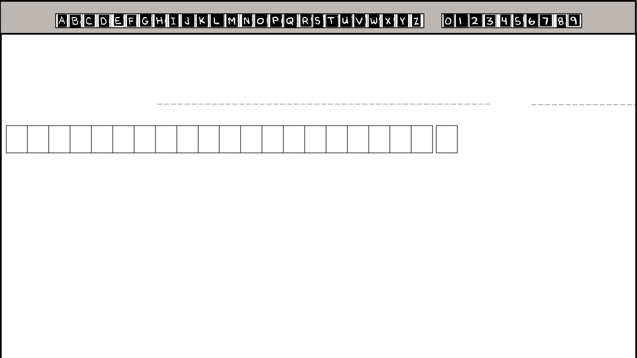
Please use a Black or Blue Pen and write your responses in PRINTED CAPITAL LETTERS without touching the sides of the boxes like the examples listed below:

Social Security Number: |  |  |  |  |  |  |  |  |  |  | Date of Birth:
 |  |  | -
 |  |  |  |  |  | - |  |  |  |  |  |  |  | / |  |  |  | /
 |  |  |  |  |  |  |  |  |  |  | Month |  |  |  |  | Day |  | Year
 |  |  |  | Fold Here |  |  |  |  |  |  |  |  |  |  |  |  |  | Fold Here

First Name |  |  |  |  |  |  |  |  |  |  |  |  |  |  |  |  |  |  |  |  |  |  |  |  |  |  |  |  |  |  |  |  |  |  |  |  |  |  |  |  |  |  |  |  |  |  |  |  |  |  |  |  |  |  |  |  |  |  |  |  |  |  |  |  |  |  |  |  |  |  | M.I.
Last Name |  |  |  |  |  |  |  |  |  |  |  |  |  |  |  |  |  |  |  |  |  |  |  |  |  |  |  |  |  |  |  |  |  |  |  |  |  |  |  |  |  |  |  |  |  |  |  |  |  |  |  |  |  |  |  |  |  |  |  |  |  |  |  |  |  |  |  |  |  |  | JR, SR, III, etc.
Current Mailing Address:
House Number |  |  |  |  |  |  | Street Name
Apartment Number / Private Mailbox |  |  |  |  |  |  |  |  |  |  |  |  |  |  |  |  |  |  |  |  |  |  |  |  | For Puerto Rico Only: Print Urbanization Name
City |  |  |  |  |  |  |  |  |  |  |  |  |  |  |  |  |  |  |  |  |  |  |  |  |  |  |  |  |  |  |  |  |  |  |  |  |  |  |  |  |  |  |  |  |  |  |  |  |  |  |  |  |  |  |  |  |  |  |  |  |  |  |  |  | State |  |  |  |  |  |  | ZipCode
Previous Mailing Address (complete only if at current mailing address for less than two years):
House Number |  |  |  |  |  |  |  | Street Name
 |  |  |  |  |  |  |  | Fold Here |  |  |  |  |  |  |  |  |  |  |  |  |  |  |  |  |  |  |  |  |  |  |  |  |  |  |  |  |  |  |  |  |  |  |  |  |  |  |  |  |  |  |  |  |  |  |  |  |  |  |  |  |  |  |  |  |  |  |  |  |  |  |  | Fold Here
Apartment Number / Private Mailbox |  |  |  |  |  |  |  |  |  |  |  |  |  |  |  |  |  |  |  |  |  |  |  |  |  | For Puerto Rico Only: Print Urbanization Name
City |  |  |  |  |  |  |  |  |  |  |  |  |  |  |  |  |  |  |  |  |  |  |  |  |  |  |  |  |  |  |  |  |  |  |  |  |  |  |  |  |  |  |  |  |  |  |  |  |  |  |  |  |  |  |  |  |  |  |  |  |  |  |  | State |  |  |  |  |  |  | ZipCode
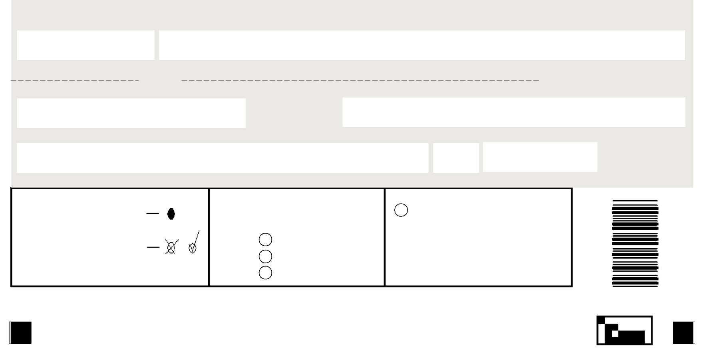
 |  | I want a credit report from (shade
Shade Circle Like This | > | each that you would like to | Shade here if, for security
 |  | receive): | reasons, you want your credit
 |  | Equifax | report to include no more than
Not Like This | > |  | the last four digits of your
 |  | Experian | Social Security Number.
 |  | TransUnion
 | If additional information is needed to process your request, the consumer credit
 |  | reporting company will contact you by mail. |  | 31238
Your request will be processed within 15 days of receipt and then mailed to you.
 |  | Copyright 2004, Central Source LLC

IDENTITY CRIME INCIDENT DETAIL FORM (page 1 of 11)

Please fill out this form and return it to the Police Dept/Sheriff’s Dept as soon as possible, or bring
it to the meeting with the detective/investigator assigned to your case. The information you provide
will be used to understand what occurred, organize the investigative case file, determine where
evidence might be found, develop a theory of how the identity crime occurred, and determine what
financial institutions should be contacted in the course of the investigation.

Date this form was filled out: _______________________________________________________

First Name: _____________________________________________________________________

Middle Name: ____________________________________________________________________

Last Name: ______________________________________________________________________

Social Security Number: ___________________________________________________________

Driver’s License Number: __________________________________________________________

Date of Birth: ____________________________________________________________________

Home Address: ___________________________________________________________________

Home Telephone Number: __________________________________________________________

Cell Phone Number: _______________________________________________________________

E-mail Address: __________________________________________________________________

Employer: _______________________________________________________________________

Work Address: ________________________________ Work Phone: _____________________

1. What is the best time to reach you at home? ________________________________________

2. How did you become aware of the identity crime?

❑ found fraudulent charges on my credit card bill
Which one? _________________________________________________________

❑ found fraudulent charges on my cellular phone bill
Which one? _________________________________________________________

❑ received bills for an account(s) I did not open
Which one? _________________________________________________________

❑ found irregularities on my credit report
❑ was contacted by a creditor demanding payment
Which one? _________________________________________________________
IDENTITY CRIME INCIDENT DETAIL FORM (page 2 of 11)

 was contacted by a bank’s fraud department regarding charges
Which one? _________________________________________________________
  was denied a loan
  was denied credit
  was arrested, had a warrant issued, or a complaint filed in my name for a crime I did not commit
Which one? _________________________________________________________
  was sued for debt that I did NOT incur
Which one? _________________________________________________________
  was not receiving bills regularly for a legitimate account (bills missing)
Which one? _________________________________________________________
  was denied employment
 had my driver’s licenses suspended for actions I did not commit
 received a legal filing I did not file, such as bankruptcy
 other (Please explain) ________________________________________________________________

________________________________________________________________________________

3. What date did you first become aware of the identity crime? ______________________________

4. When did the fraudulent activity begin? ________________________________________________

5. What is the full name, address, birth date, and other identifying information that the fraudulent
activity was made under? ___________________________________________________________

__________________________________________________________________________________

__________________________________________________________________________________

6. Please list all fraudulent activity that you are aware of to date, with the locations and addresses
of where fraudulent applications or purchases were made (retailers, banks, etc.). List in
chronological order, if possible. (EXAMPLE), “On 9/18/2002, I received a letter from MM
Collections, stating that I had accumulated $5,000 worth of charges on American Express
Account 123456789. On 9/18/2002, I called American Express and spoke with Jennifer Martin.
She informed me that the account was opened on 5/12/2002 by telephone. I did not open this
account, even though it was in my name. The account address was 123 Main St. Anytown, NE.
Ms Martin said she would send me an Affidavit of Forgery to complete and return to her.” You
may attach a separate piece of paper if you need the space. Please be concise and state the facts.

___________________________________________________________________________________

___________________________________________________________________________________

___________________________________________________________________________________

___________________________________________________________________________________

IDENTITY CRIME INCIDENT DETAIL FORM (page 3 of 11)

_________________________________________________________________________________

_________________________________________________________________________________

_________________________________________________________________________________

_________________________________________________________________________________

7. What documents and identifying information were stolen and/or compromised?
credit card(s) - List bank(s) issuing the credit cards: _______________________________

______________________________________________________________________________

ATM card - List bank issuing ATM card: _________________________________________

 checks and/or checking account number - (List bank issuing check): _________________

______________________________________________________________________________

❑ savings account passbook or number (List bank holding savings account): ______________

______________________________________________________________________________

❑ brokerage or stock accounts - (List banks and/or brokers): ____________________________

______________________________________________________________________________

passport (List country issuing passport): __________________________________________

driver’s license or license number (List the state & number): _________________________

state identity card or identity number (List state issuing card): ________________________
social security card number
birth certificate (List state and municipality issuing birth certificate): __________________

______________________________________________________________________________
resident alien card, green card, or other immigration documents
bank account passwords or “secret words”, such as mother’s maiden name

other (describe): _______________________________________________________________

_______________________________________________________________________________

_______________________________________________________________________________

❑ Unknown
IDENTITY CRIME INCIDENT DETAIL FORM (page 4 of 11)

8. To the best of your knowledge at this point, what identity crimes have been committed?

_____ making purchase(s) using my credit cards or credit card numbers without authorization

_____ opening new credit card accounts in my name

_____ opening utility and/or telephone accounts in my name

_____ unauthorized withdrawals from my bank accounts

_____ opening new bank accounts in my name

_____ taking out unauthorized loans in my name

_____ unauthorized access to my securities or investment accounts

_____ obtaining government benefits in my name

_____ obtaining employment in my name

_____ obtaining medical services or insurance in my name

_____ evading prosecution for crimes committed by using my name or committing new crimesunder my name

_____ check fraud

_____ passport/visa fraud

_____ other

9. To assist law enforcement in pinpointing when and by whom your information was compromised, it is of value to retrace your actions in recent months with regard to your personal information. This information is not solicited to "blame the victim" for the crime, but to further the investigation toward who might have stolen your personal or financial identifiers. What circumstances and activities have occurred in the last six months (include activities done by you and on your behalf by a member of your family or a friend)?

_____ carried Social Security Card in my wallet

_____ carried my bank account passwords, PINs, or codes in my wallet

_____ gave out my Social Security Number (To whom?) _________________________________________

____________________________________________________________________________________

_____ my mail was stolen (When approx.?) ____________________________________________________

_____ I went away and my mail was held at the post office or collected by someone else

_____ I traveled to another location outside my home area ( business or pleasure)

(Where did you go and when ? ) ________________________________________________________

_____________________________________________________________________________________

IDENTITY CRIME INCIDENT DETAIL FORM (page 5 of 11)

____ mail was diverted from my home (either by forwarding order or in a way unknown to you
____ I did not receive a bill as usual (i.e. credit card bill failed to come in the mail)
(Which one ? ) ______________________________________________________________
____ a new credit card I was supposed to receive did not arrive in the mail as expected
(Which one ? ) ______________________________________________________________
____ bills I was paying were left in an unlocked mailbox for pickup by the postal service
____ service people were in my home (From what company? When? ) ____________________
___________________________________________________________________________
___________________________________________________________________________
____ documentation with my personal information was thrown in the trash without beingshredded

_____ credit card bills, pre-approved credit card offers, or credit card “convenience” checks in myname were thrown out without being shredded

_____ my garbage was stolen or gone through

_____ my ATM receipts and/or credit card receipts were thrown away without being shredded

_____ my password or PIN was given to someone else

_____ my home was burglarized

_____ my car was stolen or burglarized

_____ my purse or wallet was stolen

_____ my checkbook was stolen

_____ my personal information was provided to a service business or non-profit (i.e., I gave blood,donated money, took out insurance, or saw a financial planner)

Please list: __________________________________________________________________

____________________________________________________________________________
_____
_____ my credit report was queried by someone claiming to be a legitimate business interest
(Who?) _____________________________________________________________________

_____ I applied for credit and/or authorized a business to obtain my credit report (i.e., shopped fora new car, applied for a credit card, or refinanced a home)

Please list: ___________________________________________________________________

_____________________________________________________________________________

_____ my personal information is available on the Internet, such as in an "open directory," "whitepages," genealogy web site, or college reunion web site

IDENTITY CRIME INCIDENT DETAIL FORM (page 6 of 11)

____ A legitimate purchase was made where my credit card was out of my sight

____ My personal information was given to a telemarketer or a telephone solicitor
Please list: __________________________________________________________________________

____ My personal information was given to a door-to-door salesperson or charity fundraiser
Please list: __________________________________________________________________________

____ A charitable donation was made using my personal information
Please list: __________________________________________________________________________

____ My personal information was given to enter a contest or claim a prize I had won
Please list: __________________________________________________________________________

____ A new bank account or new credit card account was legitimately opened in my name

____ I re-financed my house or property (Please list: ___________________________________________)

____ A legitimate loan was applied for or closed in my name

____ A legitimate lease was applied for or signed in my name

____ Legitimate utility accounts were applied for or opened in my name

____ A license or permit was applied for legitimately in my name

____ Government benefits were applied for legitimately in my name

____ My name and personal information were mentioned in the press, such as in the newspaper, magazine,
or on a website

____ Online purchases were made using my credit card (Through what company? _____________________

____ Personal information was included in an email

____ I released personal information to a friend or family member

For any items checked above, please, in as much detail possible, explain the circumstances of the situation:

_________________________________________________________________________________________________________________________________________________________________________________________________________________________________________________________________________________________________________________

IDENTITY CRIME INCIDENT DETAIL FORM (page 7 of 11)
10. How many purchases over the Internet (retailer or auction sites, i.e. ebay, etc. ) have you made in the
last six months? _________________

11. What Internet sites have you bought from? (List All) _________________________________________

__________________________________________________________________________________________

__________________________________________________________________________________________

12. In the last six months, whom has your Social Security Number been given to? (List All) ____________

__________________________________________________________________________________________

__________________________________________________________________________________________

__________________________________________________________________________________________

__________________________________________________________________________________________

13. Do your checks have your Social Security Number or Driver’s License Number imprinted on them?
____Yes ____No If yes, please list the retailer names where checks have been tendered

__________________________________________________________________________________________

__________________________________________________________________________________________

14. Have you written your Social Security Number or Driver’s License Number on any checks in the last six months, or has a retailer written those numbers on a check?
____Yes ____No If yes, please list the retailer names where checks have been tendered

__________________________________________________________________________________________

__________________________________________________________________________________________

15. Do you own a business or businesses that may be affected by this identity crime?
____Yes ____No If yes, please list the retailer names where checks have been tendered

__________________________________________________________________________________________

__________________________________________________________________________________________

16. Do you have any information on a suspect in this identity crime case? ___________________________
How do you believe the theft occurred? ____________________________

__________________________________________________________________________________________

__________________________________________________________________________________________

IDENTITY CRIME INCIDENT DETAIL FORM (page 8 of 11)

17. Please list all the banks that you have accounts with. Place an asterisk (*) by accounts that have fraudulent charges on them.

Bank Type of account and account number (checking, savings, pension, etc. Fraudulent charges?

__________________________________________________________________________________________

__________________________________________________________________________________________

__________________________________________________________________________________________

__________________________________________________________________________________________

__________________________________________________________________________________________

18. Please list all the credit card companies and banks that you have credit cards with. Place an asterisk (*) next to accounts that have fraudulent charges on them.

__________________________________________________________________________________________

__________________________________________________________________________________________

__________________________________________________________________________________________

__________________________________________________________________________________________

__________________________________________________________________________________________

19. Please list all the utility companies (i.e. Power, Water, etc.) you have accounts with. Place an asterisk (*) next to accounts that have fraudulent charges on them.

__________________________________________________________________________________________

__________________________________________________________________________________________

__________________________________________________________________________________________

__________________________________________________________________________________________

__________________________________________________________________________________________

IDENTITY CRIME INCIDENT DETAIL FORM (page 9 of 11)

20. Please list all the financial institutions you have loans, leases, and mortgages from. Place an asterisk (*) next to accounts that have fraudulent charges on them.

Financial Institution Type of account and account# (loan, lease, mortgage,etc) Fraudulent charges?

__________________________________________________________________________________________

__________________________________________________________________________________________

__________________________________________________________________________________________

__________________________________________________________________________________________

__________________________________________________________________________________________

21. Please list any merchants who you have credit accounts with such as department stores, or retailers. Place an asterisk (*) next to accounts that have fraudulent charges on them.

__________________________________________________________________________________________

__________________________________________________________________________________________

__________________________________________________________________________________________

__________________________________________________________________________________________

__________________________________________________________________________________________

22. Please list any other financial institutions where fraudulent accounts were opened in your name or using your personal identifiers.

__________________________________________________________________________________________

__________________________________________________________________________________________

__________________________________________________________________________________________

__________________________________________________________________________________________

__________________________________________________________________________________________

__________________________________________________________________________________________

IDENTITY CRIME INCIDENT DETAIL FORM (page 10 of 11)

23. Please list any documents fraudulently obtained in your name (driver’s license, social security cards, etc.)

___________________________________________________________________________________________

___________________________________________________________________________________________

___________________________________________________________________________________________

___________________________________________________________________________________________

___________________________________________________________________________________________

___________________________________________________________________________________________

24. Have you contacted the following organizations and requested a Fraud Alert be put on your accounts? (Check all that you have contacted about a Fraud Alert)

_____ Equifax On what date? _________________________________

_____TransUnion On what date? _________________________________

_____Experian On what date? __________________________________

_____ Your Bank(s) Name of Bank(s): ___________________________________________

____________________________________________

_____ Department of Motor Vehicles

_____ Social Security Administration

_____ Other: (Please list) ___________________________________________________________________

25. Have you requested a credit report from each of the three credit bureaus? (Check all that you have requested a credit report from)

_____ Equifax (if you have the credit report in your possession, please attach a copy to this form)

______ TransUnion (if you have the credit report in your possession, please attach a copy to this form)

______ Experian (if you have the credit report in your possession, please attach a copy to this form)

IDENTITY CRIME INCIDENT DETAIL FORM (page 11 of 11)

26. Have you contacted any financial institution, concerning either legitimate or fraudulently opened accounts? If yes, please list:

Name of financial institution _____ Phone number _____ Person you spoke with

___________________________________________________________________________________________

___________________________________________________________________________________________

___________________________________________________________________________________________

___________________________________________________________________________________________

___________________________________________________________________________________________

___________________________________________________________________________________________

*** Please bring with you to the meeting with a detective/investigator : all account statements, letters, correspondence, phone records, credit reports, and other documents regarding this case.

Also please make a copy of this completed form for your records.

Remember to keep a detailed log of all your correspondence and contacts since realizing you were the victim of identity crime.

Identity Theft – Resources

www.annualcreditreport.com (free credit reports)

Addresses for Disputes of Credit Reports  Experian  NCAC  P.O. Box 9556  Allen, TX 75013  Equifax Information Services  P.O. Box 740256  Atlanta, GA 30374  TransUnion  Customer Disclosure Center  TransUnion Consumer Relations  P.O. Box 2000  Chester, PA 19022-2000  When mailing your request, be sure and send all of the information required of the credit bureaus. | Contact Numbers for Credit Reporting Agencies  Experian  Office in Texas: 1-888-397-3742  Business: 1-888-211-0728  Equifax Information Services  Business Line (with option for personal): 1-888-202-4025  Office in Georgia: 1-800-685-1111  Dispute Fax #: 1-888-826-0573  Business: 1-802-304-0364  General: 1-800-797-6801  TransUnion  Office in Pennsylvania: 1-800-888-4213  1-888-259-6845 (6am-12 pacific time)  1-800-916-8800 (consumer relations)

